

CLASS : XIITH SUBJECT : PHYSICS
DATE : DPP NO. : 4
Topic :- Current Electricity

1. The smallest temperature difference that can be measured with a combination of a thermocouple of thermo $e$.m.f. $30 μV$ per degree and a galvanometer of $50 ohm$ resistance, capable of measuring a minimum current of $3×{10}^{-7}amp$ is
a) 0.5 degree b) 1.0 degree c) 1.5 degree d)2.0 degree

2. The magnitude and direction of the current in the circuit shown will be
d
c
b
a
1Ω
10V
e
4V
2Ω
3Ω
a) $7/3A$ from $a$ to $b$ through $e$ b) $7/3A$ from $b$ to $a$ through $e$
c) $1A$ from $b$ to $a$ through $e$ d) $1A$ from $a$ to $b$ through $e$

3. If the cold junction is held at $0℃,$ the same thermo-emf $V$ of a thermocouple varies as $V=10×{10}^{-6} t-\frac{1}{40}×{10}^{-6} t^{2},$ where $t$ is the temperature of the hot junction in $℃.$ The neutral temperature and the maximum value of thermo-emf are respectively
a) $200℃;2 mV$ b) $400℃;2 mV$ c) $100℃;1 mV$ d)$200℃;1 mV$

4. A voltmeter has a range $0-V$ with a series resistance $R.$ With a series resistance $2R,$ the range is $0-V^{'}.$ The correct relation between $V$and $V'$ is
a) $V^{'}=2V$ b) $V^{'}>2V$ c) $V^{'}≫2V$ d) $V^{'}<2V$

5. A potentiometer wire of length $L$ and resistance $10 Ω$ is connected in series with a battery of e.m.f. $2.5 V$ and a resistance in its primary circuit. The null point corresponding to a cell of e.m.f. $1V$ is obtained at a distance $\frac{L}{2}.$ If the resistance in the primary circuit is doubled then the position of new null point will be
a) $0.4 L$ b) $0.5 L$ c) $0.6 L$ d) $0.8 L$

6. The ratio of voltage sensitivity ($V_{S}$) and current sensitivity ($I_{s}$) of a moving coil galvanometer is
a) $\frac{1}{G}$ b) $\frac{1}{G^{2}}$ c) G d) $G^{2}$

7. Find the power of the circuit
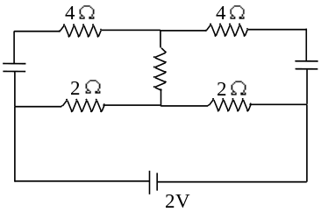
a) $1.5 W$ b) $2 W$ c) $1 W$ d) None of these

8. Five conductors are meeting at a point x as shown in the figure. What is the value of current in fifth conductor?
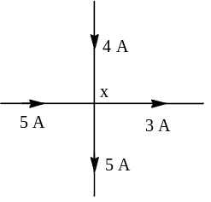
a) 3 A away from x b) 1 A away from x c) 4 A away from x d) 1 A towards x

9. A heating coil is labelled $100 W, 220 V.$ The coil is cut in half and the two pieces are joined in parallel to the same source. The energy now liberated per second is
a) $200 J$ b) $400 J$ c) $25 J$ d) $50 J$

10. For comparing the e.m.f.'s of two cells with a potentiometer, a standard cell is used to develop a potential gradient along the wires. Which of the following possibilities would make the experiment unsuccessful
a) The e.m.f. of the standard cell is larger than the $E$ e.m.f.'s the two cells
b) The diameter of the wires is the same and uniform throughout
c) The number of wires is ten
d) The e.m.f. of the standard cell is smaller than the e.m.f.'s of the two cells

11. Two different metals are joined end to end. One end is kept at constant temperature and the other end is heated to a very high temperature. The high depicting the thermo $e$.m.f. is
a) b) c) d)
E
t
E
t
E
t
E
t

12. In the circuit element given here, if the potential at point $B, V_{B}=0,$ then the potentials of $A$ and $D$ are given as
A
B
C
D
1 amp
1.5 Ω
2.5 Ω
2V
a) $V_{A}=-1.5V, V_{D}=+2V$ b) $V_{A}=+1.5V, V_{D}=+2V$
c) $V_{A}=+1.5 V,V_{D}=+0.5 V$ d) $V_{A}=+1.5V, V_{D}=-0.5 V$

13. If in the circuit shown below, the internal resistance of the battery is $1.5 Ω$ and $V_{P}$and$V_{Q}$ are the potentials at $P$ and $Q$ respectively, what is the potential difference between the points $P$ and $Q$
2 Ω
P
Q
20 V
3 Ω
3 Ω
2 Ω
1.5 Ω
+
–
a) Zero b)$4 volts (V_{P}>V_{Q})$ c)$4 volts (V_{Q}>V_{P})$ d) $2.5 volts (V_{Q}>V_{P})$

14. Two resistance of $10 Ω$ and $20 Ω$ and an inductor of inductance $5 H$ are connected to a battery of $2 V$ through a key $k$ as shown in the figure. At time $t=0,$ when the key $k$ is closed the initial current through the battery is
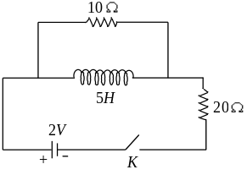
a) $0.2 A$ b) $\frac{2}{15}A$ c) $\frac{1}{15}A$ d) 0

15. Find the equivalent resistance across the terminals of source of e.m.f. $24 V$ for the circuit shown in figure
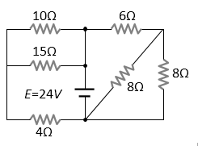
a) $15 Ω$ b) $10 Ω$ c) $5 Ω$ d) $4 Ω$

16. Twelve cells, each having emf E volts are connected in series and kept in a closed box. Some of these cells are wrongly connected with positive and negative terminals reversed. This 12-cell battery is connected with an ammeter, an external resistance R ohm and a two-cell battery (two cells of the same type used earlier, connected perfectly in series). The current in the circuit when the 12-cell battery and 2-cell battery aid each other is 3A and 2A when they oppose each other. Then, the number of cell in 12-cell battery that are connected wrongly is
a) 4 b) 3 c) 2 d)

17. In hydrogen atom, the electron makes $6.6×{10}^{15}$ revolutions per second around the nucleus in an orbit of radius $0.5×{10}^{-10}m.$ It is equivalent to a current nearly
a) $1 A$ b) $1 mA$ c) $1 μA$ d) $1.6×{10}^{-19}A$

18. Two conductors made of the same material are connected across a common potential difference. Conductor $A$ has twice the diameter and twice the length of conductor $B.$ The power delivered to the two conductors $P_{A}$ and $P_{B}$ respectively is such that $P_{A}/P_{B}$ equals to
a) 0.5 b) 1.0 c)1.5 d) 2.0

19. Two heater wires of equal length are first connected in series and then in parallel. The ratio of heat produced in the two cases is
a)1 : 4 b)4 : 1 c)1 : 2 d) 2 : 1

20. Consider the following statements regarding the network shown in the figure.
1. The equivalent resistance of the network between point A and B is independent of value of G.
2. The equivalent resistance of the network between points A and B is
$$\frac{4}{3}R$$
3. The current through G is zero.
Which of the above statements is/zero true?
2R
2R
E
A
R
R
B
G
a) 1,2 and 3 b) 2 and 3 c) 2 alone d) 1 alone

